**E-puck Sensors Extension: Example of groundSensorSlot**

**Important:** The purpose of this tutorial is to guide you through the process of extending the e-puck with additional sensors, such as the groundSensorSlot in this example, to meet the application requirements. For your project, I don't see a specific need for this particular sensor, but you may require other types of sensors where this tutorial could be useful.

Open your assigned webots project

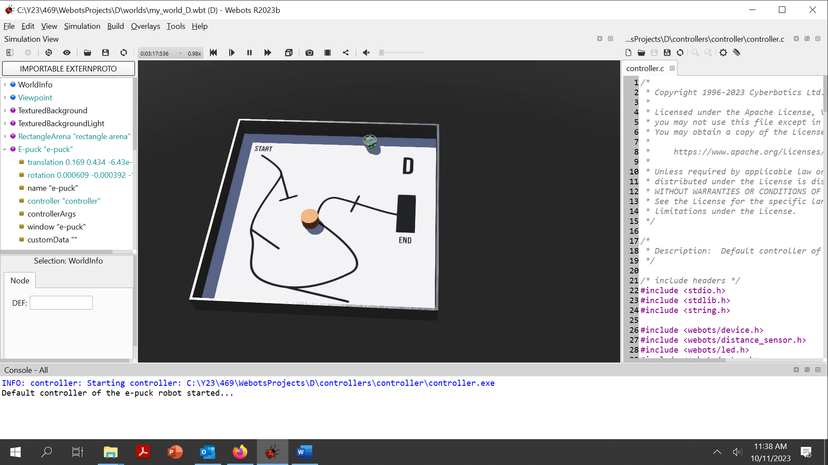

Simulation control buttons

To add a ground sensor, follow these steps:

1. Expand “Epuck” node by clicking on “>”

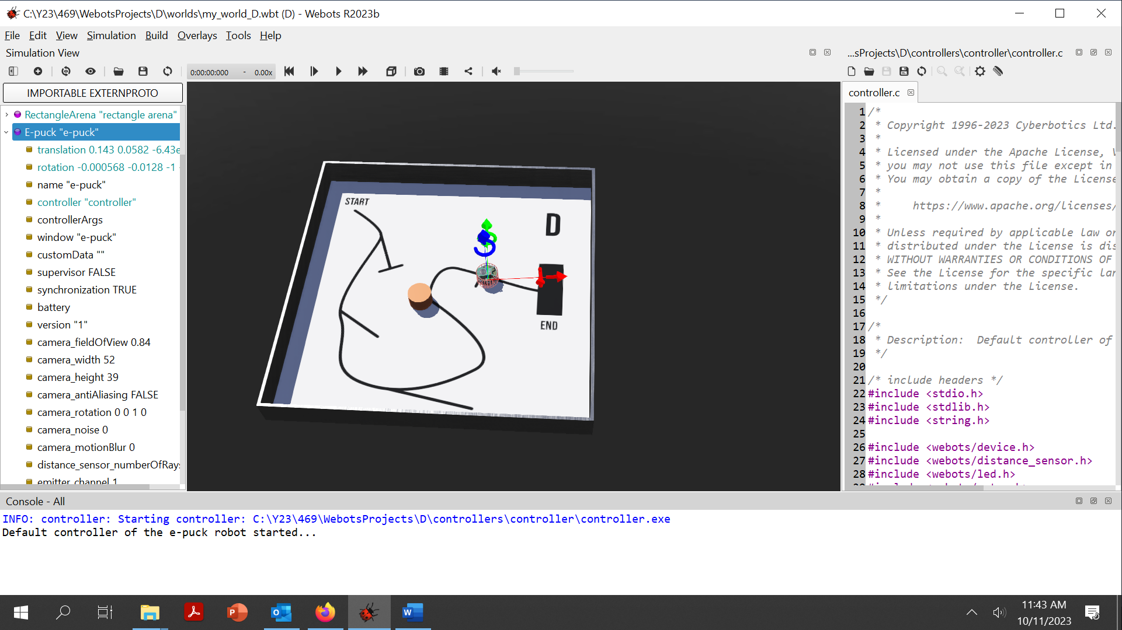

1. Right click on “groundSensorsSlot” and select “Add New”

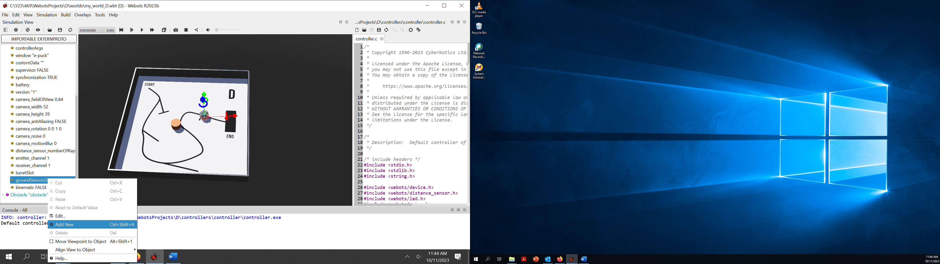

1. Expand “Base nodes” and select “DistanceSensor”

1. Rename the distance sensor by clicking on Distance Sensor (give a more descriptive name)

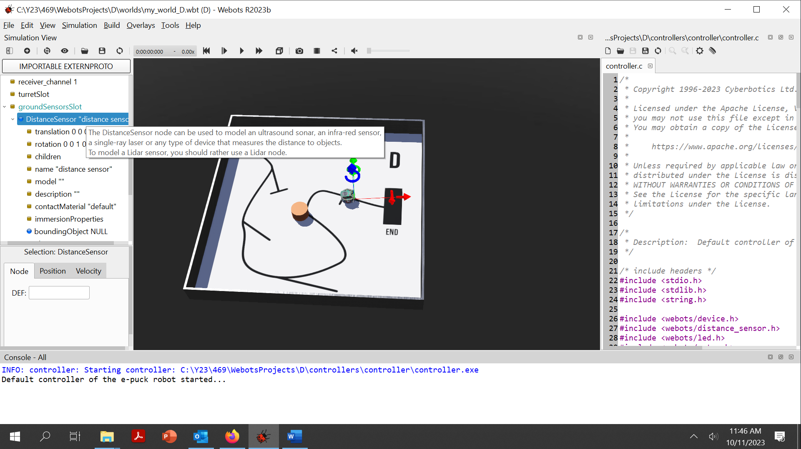

1. Click on “Translation” to change the position of the sensor through the x (red axis), y (green axis) and z (blue axis) fields. The values can be positive or negative.

Use the computer mouse to zoom in and out ; furthermore, the control from the Menu bar View🡪 “Change view” allows you to view the robot environment from different angles.

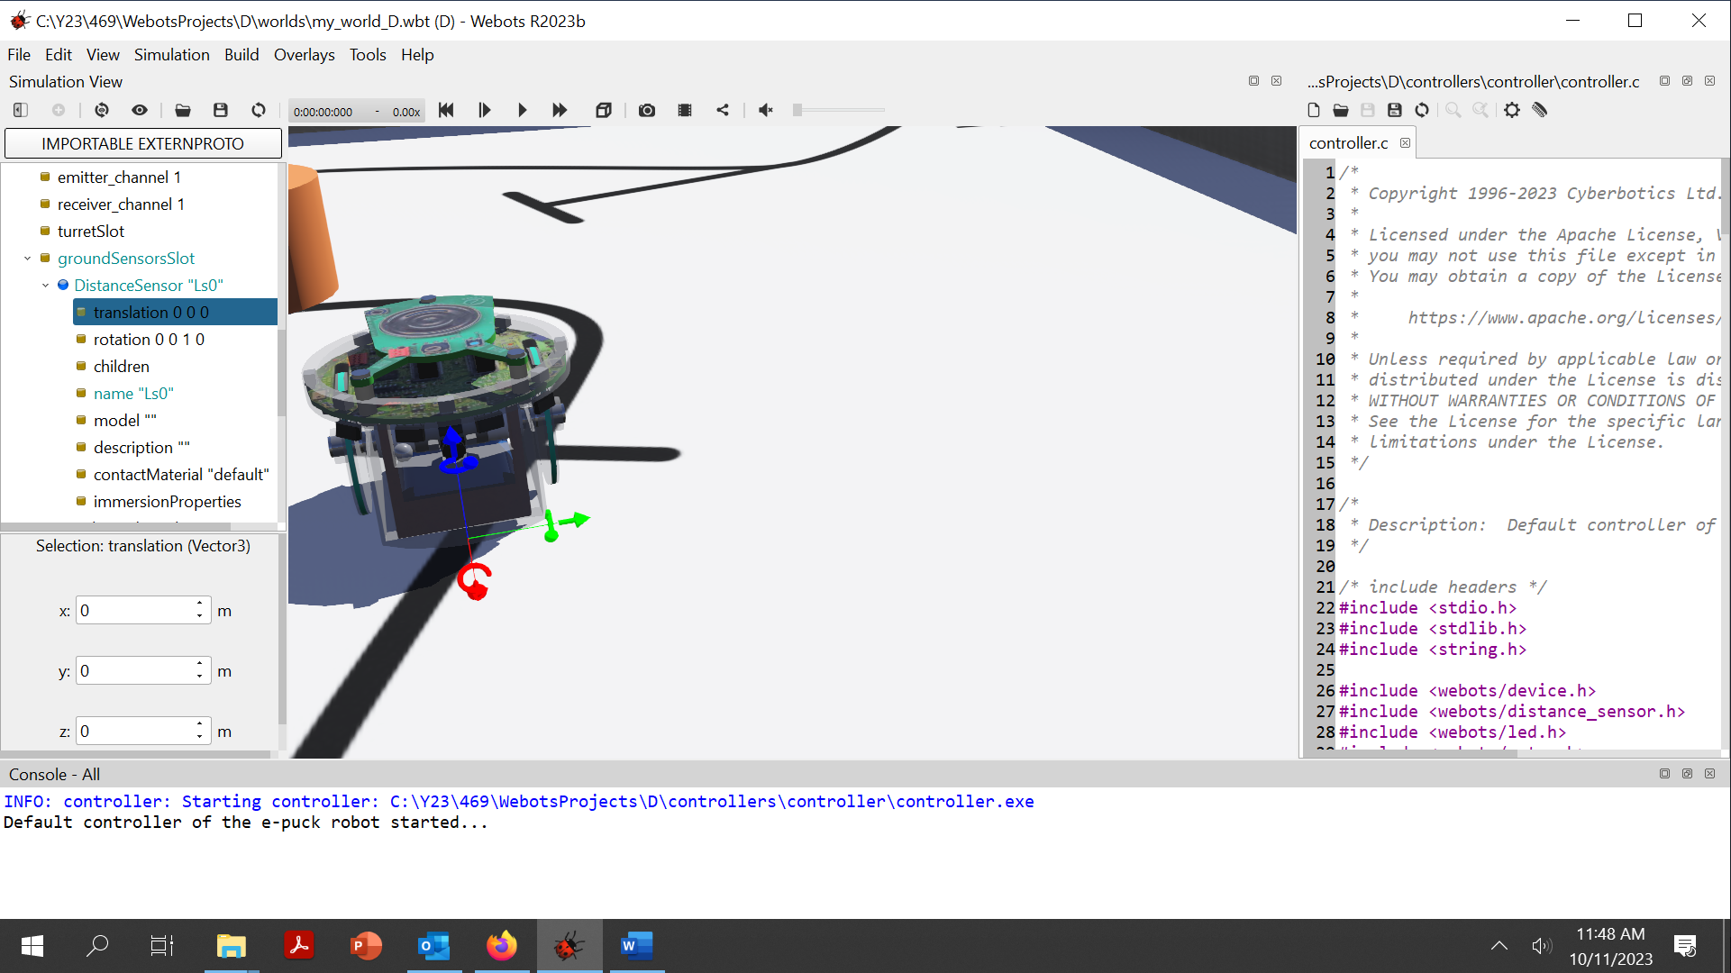

In the below, the sensor is moved to the right with y=-0.01

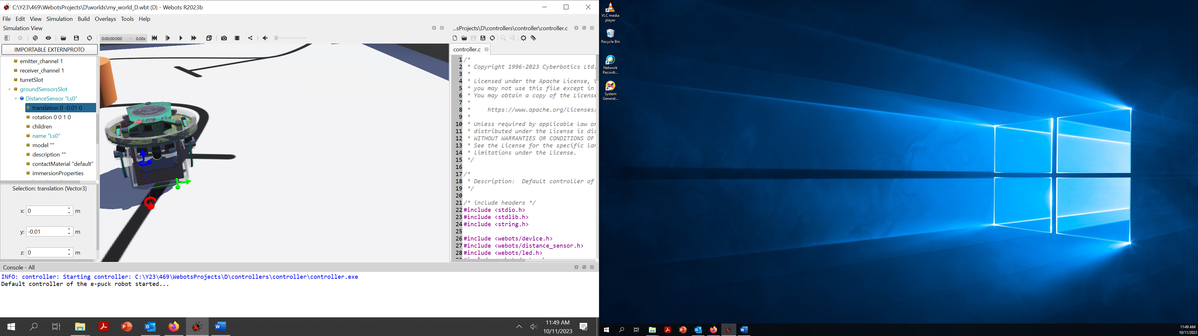

To see the sensors emitted lights, select “Show DistanceSensor Rays” from Menu bar View🡪Original Rendering. A white beam emerges from the sensor.

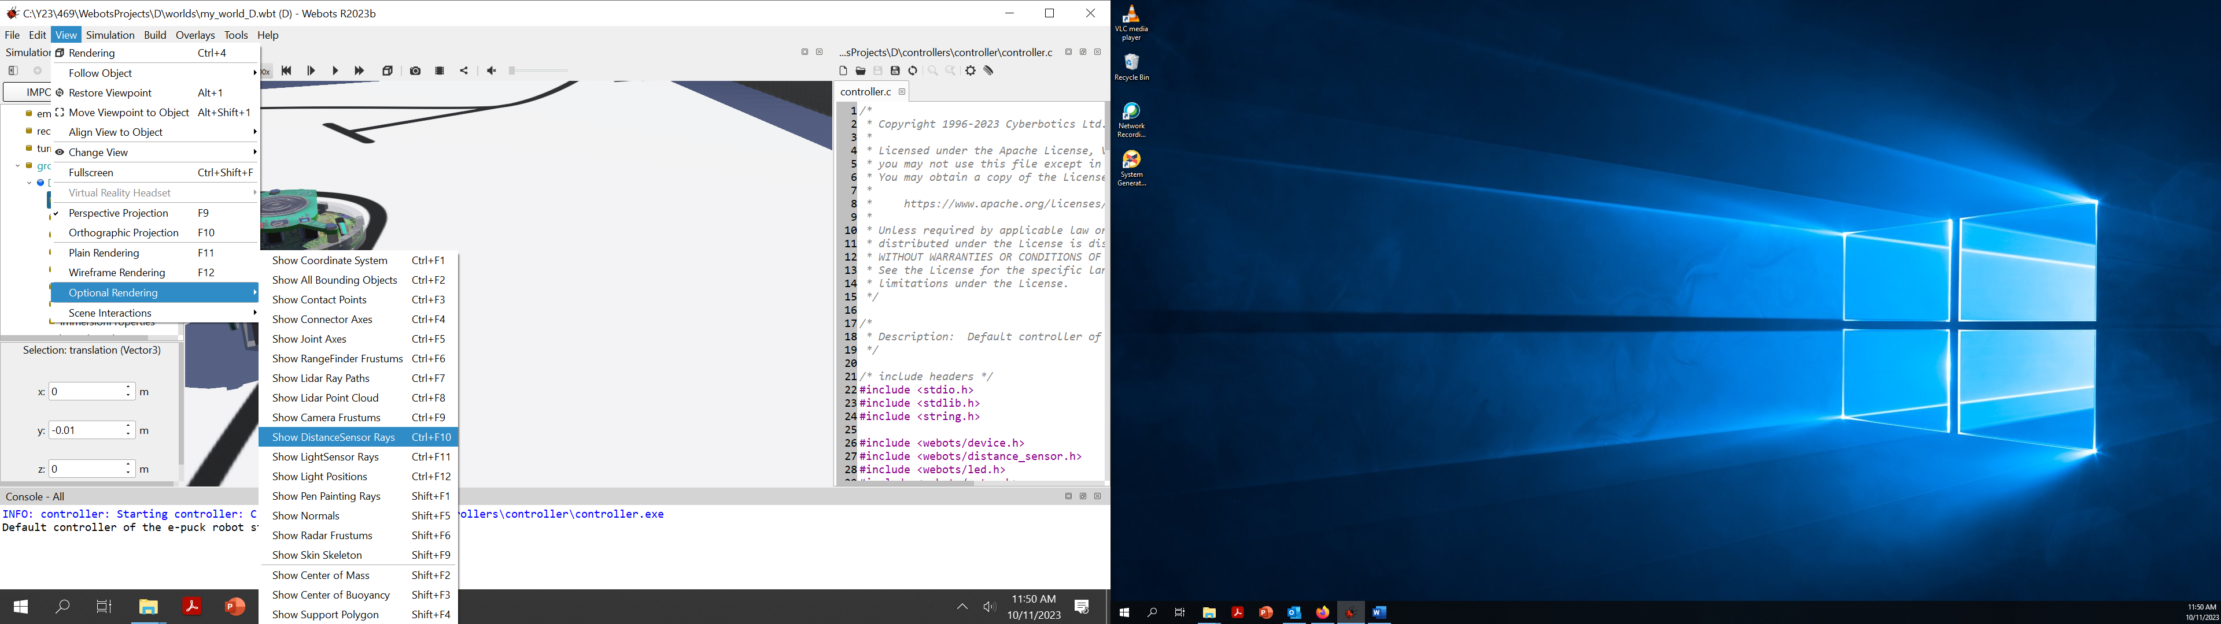

1. To point the sensor / beam onto the floorplan

Click on “rotation” field and edit x, y, z and angle as below (note PI/2= 1.75)

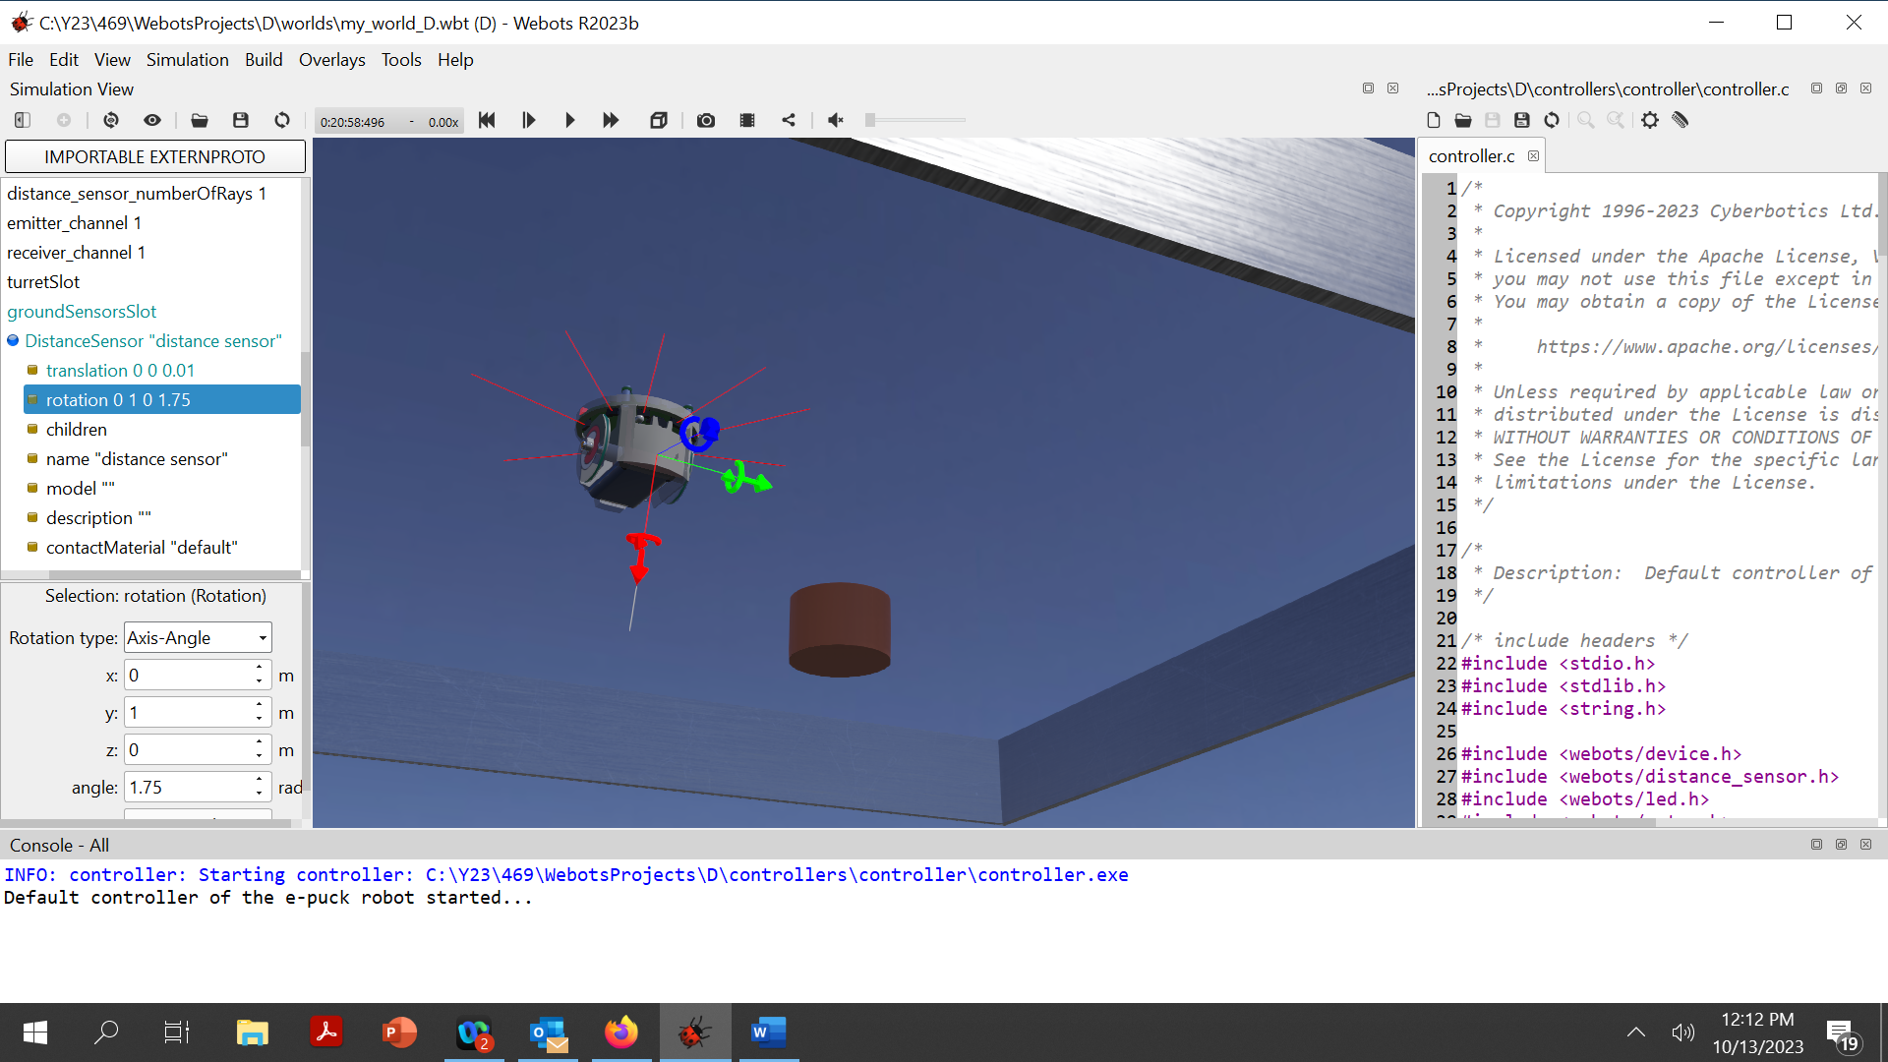

To add a new sensor, follow again the above steps starting from 2.